**Multi Node Cluster in Hadoop 2.x**

From our previous blog in [**Hadoop Tutorial Series**](http://www.edureka.co/blog/hadoop-tutorial/?utm_source=blog&utm_medium=content-link&utm_campaign=multi-node-cluster-in-hadoop), we learnt how to setup a[**Hadoop Single Node Cluster**](http://www.edureka.co/blog/install-hadoop-single-node-hadoop-cluster?utm_source=blog&utm_medium=content-link&utm_campaign=multi-node-cluster-in-hadoop). Now, I will show how to set up a ***Hadoop Multi Node Cluster***. A Multi Node Cluster in Hadoop contains two or more DataNodes in a distributed Hadoop environment. This is practically used in organizations to store and analyze their Petabytes and Exabytes of data.

Here, we are taking two machines – **master** and **slave**. On both the machines, a Datanode will be running.

Let us start with the setup of Multi Node Cluster in Hadoop.

**Prerequisites**

* Cent OS 6.5
* Hadoop-2.7.3
* JAVA 8
* SSH

**Setup of Multi Node Cluster in Hadoop**

We have two machines (master and slave) with IP:

Master IP: **192.168.56.102**

Slave IP: **192.168.56.103**

**STEP 1:** Check the IP address of all machines.

***Command:*** ip addr show (you can use the ***ifconfig*** command as well)

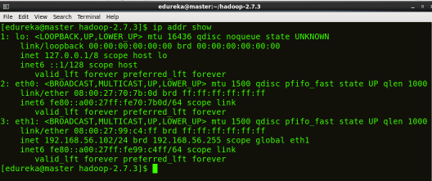

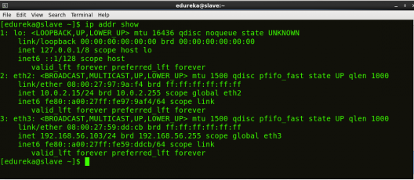

**STEP 2:** Disable the firewall restrictions.

***Command:*** service iptables stop

***Command:*** sudo chkconfig iptables off

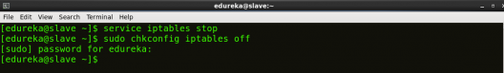

**STEP 3:** Open hosts file to add master and data node with their respective IP addresses.

***Command:*** sudo nano /etc/hosts

Same properties will be displayed in the master and slave hosts files.

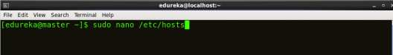

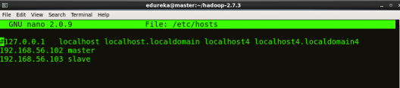

**STEP 4:** Restart the sshd service.

***Command:*** service sshd restart

ssh Service Restart - Hadoop Multi Node Cluster - Edureka

**STEP 5:** Create the SSH Key in the master node. (Press enter button when it asks you to enter a filename to save the key).

***Command:*** ssh-keygen -t rsa -P “”

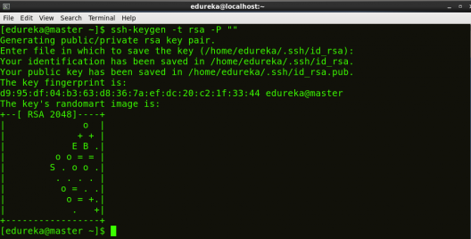

**STEP 6:** Copy the generated ssh key to master node’s authorized keys.

***Command:*** cat $HOME/.ssh/id_rsa.pub >> $HOME/.ssh/authorized_keys

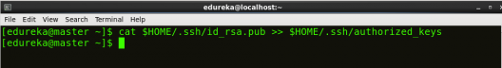

**STEP 7:**Copy the master node’s ssh key to slave’s authorized keys.

***Command:***ssh-copy-id -i $HOME/.ssh/id_rsa.pub edureka@slave

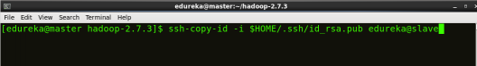

**STEP 8:** [Click here](https://goo.gl/B2BAk2) to download the Java 8 Package. Save this file in your home directory.

**STEP 9:** Extract the Java Tar File on all nodes.

***Command*:** tar -xvf jdk-8u101-linux-i586.tar.gz

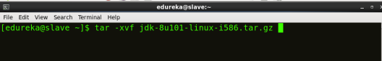

**STEP 10:** Download the Hadoop 2.7.3 Package on all nodes.

***Command*:** wget https://archive.apache.org/dist/hadoop/core/hadoop-2.7.3/hadoop-2.7.3.tar.gz

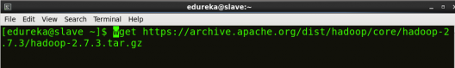

**STEP 11:** Extract the Hadoop tar File on all nodes.

***Command*:** tar -xvf hadoop-2.7.3.tar.gz

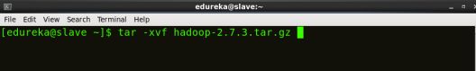

**STEP 12:** Add the Hadoop and Java paths in the bash file (.bashrc) on all nodes.

Open**.** **bashrc** file. Now, add Hadoop and Java Path as shown below:

***Command*:**  sudo gedit .bashrc

Open bashrc - Hadoop Multi Node Cluster - Edureka

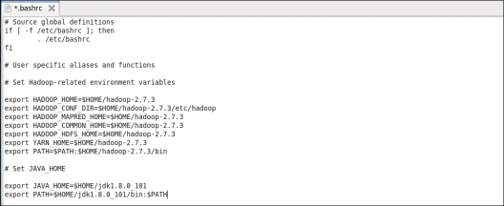

Then, save the bash file and close it.

For applying all these changes to the current Terminal, execute the source command.

***Command*:** source .bashrc

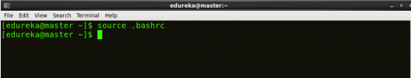

To make sure that Java and Hadoop have been properly installed on your system and can be accessed through the Terminal, execute the java -version and hadoop version commands.

***Command*:** java -version

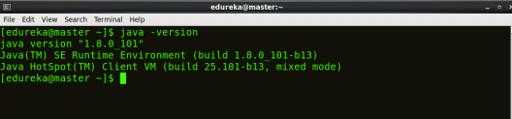

***Command*:** hadoop version

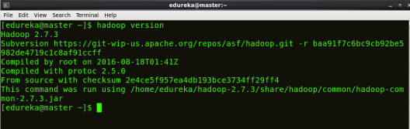

Now edit the configuration files in **hadoop-2.7.3/etc/hadoop** directory.

**STEP 13:** Create masters file and edit as follows in both master and slave machines as below:

***Command***: sudo gedit masters

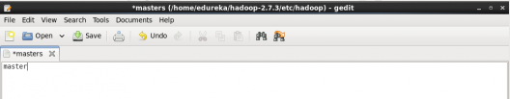

**STEP 14:** Edit slaves file in master machine as follows:

***Command:*** sudo gedit /home/edureka/hadoop-2.7.3/etc/hadoop/slaves

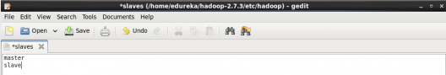

**STEP 15:** Edit slaves file in slave machine as follows:

***Command:*** sudo gedit /home/edureka/hadoop-2.7.3/etc/hadoop/slaves

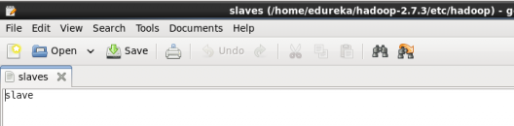

**STEP 16:** Edit core-site.xml on both master and slave machines as follows:

***Command:*** sudo gedit /home/edureka/hadoop-2.7.3/etc/hadoop/core-site.xml

open core-site - Hadoop Multi Node Cluster - Edureka

|  |  |
| --- | --- |
| 1  2  3  4  5  6  7  8 | <?xml version="1.0" encoding="UTF-8"?>  <?xml-stylesheet type="text/xsl" href="configuration.xsl"?>  <configuration>  <property>  <name>fs.default.name</name>  <value><hdfs://master:9000></value>  </property>  </configuration> |

**STEP 7:** Edit hdfs-site.xml on master as follows:  
***Command:*** sudo gedit /home/edureka/hadoop-2.7.3/etc/hadoop/hdfs-site.xml

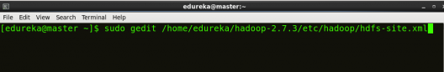

|  |  |
| --- | --- |
| 1  2  3  4  5  6  7  8  9  10  11  12  13  14  15  16  17  18  19  20 | <?xml version="1.0" encoding="UTF-8"?>  <?xml-stylesheet type="text/xsl" href="configuration.xsl"?>  <configuration>  <property>  <name>dfs.replication</name>  <value>2</value>  </property>  <property>  <name>dfs.permissions</name>  <value>false</value>  </property>  <property>  <name>dfs.namenode.name.dir</name>  <value>/home/edureka/hadoop-2.7.3/namenode</value>  </property>  <property>  <name>dfs.datanode.data.dir</name>  <value>/home/edureka/hadoop-2.7.3/datanode</value>  </property>  </configuration> |

**STEP 18:** Edit hdfs-site.xml on slave machine as follows:

***Command:*** sudo gedit /home/edureka/hadoop-2.7.3/etc/hadoop/hdfs-site.xml

|  |  |
| --- | --- |
| 1  2  3  4  5  6  7  8  9  10  11  12  13  14  15  16 | <?xml version="1.0" encoding="UTF-8"?>  <?xml-stylesheet type="text/xsl" href="configuration.xsl"?>  <configuration>  <property>  <name>dfs.replication</name>  <value>2</value>  </property>  <property>  <name>dfs.permissions</name>  <value>false</value>  </property>  <property>  <name>dfs.datanode.data.dir</name>  <value>/home/edureka/hadoop-2.7.3/datanode</value>  </property>  </configuration> |

**STEP 19:** Copy mapred-site from the template in configuration folder and the edit mapred-site.xml on both master and slave machines as follows:

***Command:*** cp mapred-site.xml.template mapred-site.xml

***Command:*** sudo gedit /home/edureka/hadoop-2.7.3/etc/hadoop/mapred-site.xml

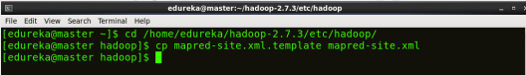

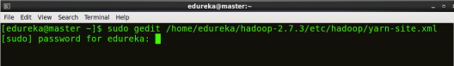

|  |  |
| --- | --- |
| 1  2  3  4  5  6  7  8 | <?xml version="1.0" encoding="UTF-8"?>  <?xml-stylesheet type="text/xsl" href="configuration.xsl"?>  <configuration>  <property>  <name>mapreduce.framework.name</name>  <value>yarn</value>  </property>  </configuration> |

**STEP 20:** Edit yarn-site.xml on both master and slave machines as follows:

***Command:*** sudo gedit /home/edureka/hadoop-2.7.3/etc/hadoop/yarn-site.xml



|  |  |
| --- | --- |
| 1  2  3  4  5  6  7  8  9  10  11  12 | <?xml version="1.0" encoding="UTF-8"?>  <?xml-stylesheet type="text/xsl" href="configuration.xsl"?>  <configuration>  <property>  <name>yarn.nodemanager.aux-services</name>  <value>mapreduce_shuffle</value>  </property>  <property>  <name>yarn.nodemanager.auxservices.mapreduce.shuffle.class</name>  <value>org.apache.hadoop.mapred.ShuffleHandler</value>  </property>  </configuration> |

**STEP 21:** Format the namenode (Only on master machine).

***Command:*** hadoop namenode -format

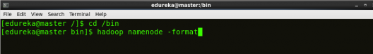

**STEP 22:** Start all daemons (Only on master machine).

***Command:*** ./sbin/start-all.sh

start-all daemon - Hadoop Multi Node Cluster - Edureka

**STEP 23:** Check all the daemons running on both master and slave machines.

***Command:***jps

***On master***

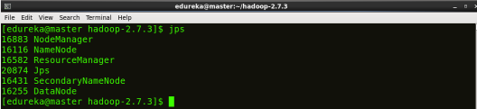

***On slave***

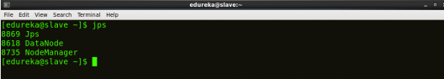

At last, open the browser and go to **master**:**50070/dfshealth.html** on your master machine, this will give you the NameNode interface. Scroll down and see for the number of **live nodes**, if its **2**, you have successfully setup a multi node Hadoop cluster. In case, it’s not 2, you might have missed out any of the steps which I have mentioned above. But no need to worry, you can go back and verify all the configurations again to find the issues and then correct them.

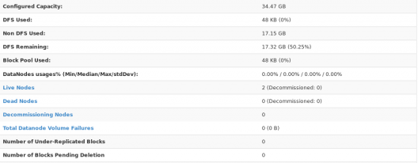

Here, we have only 2 DataNodes. If you want, you can add more DataNodes according to your needs, refer our blog on [**Commissioning and Decommissioning Nodes in a Hadoop Cluster**](http://www.edureka.co/blog/commissioning-and-decommissioning-nodes-in-a-hadoop-cluster/?utm_source=blog&utm_medium=content-link&utm_campaign=multi-node-cluster-in-hadoop).

I hope you would have successfully installed a Hadoop Multi Node Cluster. If you are facing any problem, you can comment below, we will be replying shortly. In our next blog of [**Hadoop Tutorial Series**](http://www.edureka.co/blog/hadoop-tutorial/?utm_source=blog&utm_medium=content-link&utm_campaign=multi-node-cluster-in-hadoop)**,** you will learn some important [**HDFS commands**](http://www.edureka.co/blog/hdfs-commands-hadoop-shell-command?utm_source=blog&utm_medium=content-link&utm_campaign=multi-node-cluster-in-hadoop) and you can start playing with Hadoop.

[<< Previous Blog](http://www.edureka.co/blog/install-hadoop-single-node-hadoop-cluster?utm_source=blog&utm_medium=blog-cta&utm_campaign=multinode-hadoop-installation-p)   [Next Blog >>](http://www.edureka.co/blog/hdfs-commands-hadoop-shell-command?utm_source=blog&utm_medium=blog-cta&utm_campaign=multinode-hadoop-installation-n)